Software requirement specification

On

POLYGON

# Prepared by: Bandi Dinesh Kumar

# Organisation: Niit University

# Date created: September 16 2016

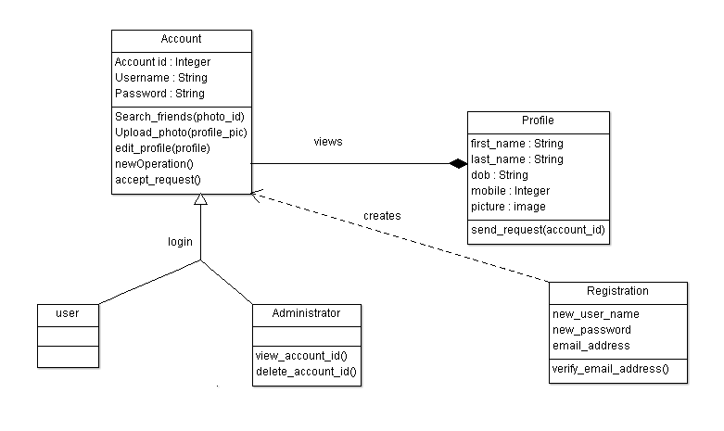

Table of Contents

Table of Contents ii

Revision History ii

1. Introduction 1

1.1 Purpose 1

1.2 Document Conventions 1

1.3 Intended Audience and Reading Suggestions 1

1.4 Product Scope 1

1.5 References 1

2. Overall Description 2

2.1 Product Perspective 2

2.2 Product Functions 2

2.3 User Classes and Characteristics 2

2.4 Operating Environment 2

2.5 Design and Implementation Constraints 2

2.6 User Documentation 2

2.7 Assumptions and Dependencies 3

3. External Interface Requirements 3

3.1 User Interfaces 3

3.2 Hardware Interfaces 3

3.3 Software Interfaces 3

3.4 Communications Interfaces 3

4. System Features 4

4.1 System Feature 1 4

5. Other Nonfunctional Requirements 4

5.1 Performance Requirements 4

5.2 Safety Requirements 5

5.3 Security Requirements 5

5.4 Software Quality Attributes 5

5.5 Business Rules 5

6. Other Requirements 5

Appendix A: Glossary 5

Appendix B: Analysis Models 5

Appendix C: To Be Determined List 6

Revision History

|  |  |  |  |
| --- | --- | --- | --- |
| **Name** | **Date** | **Reason For Changes** | **Version** |
|  |  |  |  |
|  |  |  |  |

**1. INTRODUCTION:**

**1.1 PURPOSE**

This SRS document is prepared to understand the concept of our project that is polygon .The main goal of the system is to overcome the communication barriers .The document gives you clarity about the system and the core features of polygon. Polygon 1.0 version will be available to all the students in a particular organization (currently only for NIIT University).

**1.2 DOCUMENT CONVENTIONS**

Arial italic – standard type style used for most text, Times bold-used for headings and for index. The document doesn’t contain any special symbols. Every requirement statement in the document has its own priority.

**1.3 INTENDED READERS**

This is a project by the student of Niit University and the main head of this project is Mr. Amit Kumar sir. So the main reader will be the project head and this srs document is also a reading purpose for other developers if any other wants to develop our applications.The document consists of the table of contents in the first page so the reader can follow accordingly.pleople to understand the UI can begin with the 3rd chapter and 4th chapter to know the system features.

**1.4 PRODUCT SCOPE**

Polygon app Polygon app can be used to know about the people around you with just one click. Provided. Our goal is to let students of same interests in a college to know each other and make them work together. The people working together can be more productive and also they will learn working in team. Our app also has scope of being used as an automatic student attendance system, college has to provide students with the app and one student can join other, our corporate goal is to reach to all the colleges across the country and to be in the hands of every student.

**1.5 REFERENCE**

The SRS document has been prepared by taking IEEE830 document as a reference and the use case diagram has been prepared by referring to the standard social networking use case diagram.

Reference link: http://image.slidesharecdn.com/random-140623014539-phpapp01/95/social-networking-site-23-638.jpg?cb=1403487994

**2. OVERALL DESCRIPTION**

**2.1 PRODUCT PERSPECTIVE**

Polygon is a new product in this social networking market which was created for students and educational organizations. The app requires a third party application face-plus-plus support for face recognition algorithm and database support.

**2.2 PRODUCT FUNCTIONS**

The user have to sign-up if he is a new user and the existing user can directly use the product. User should be able to send photo requests to the server and has to be able to receive their information.

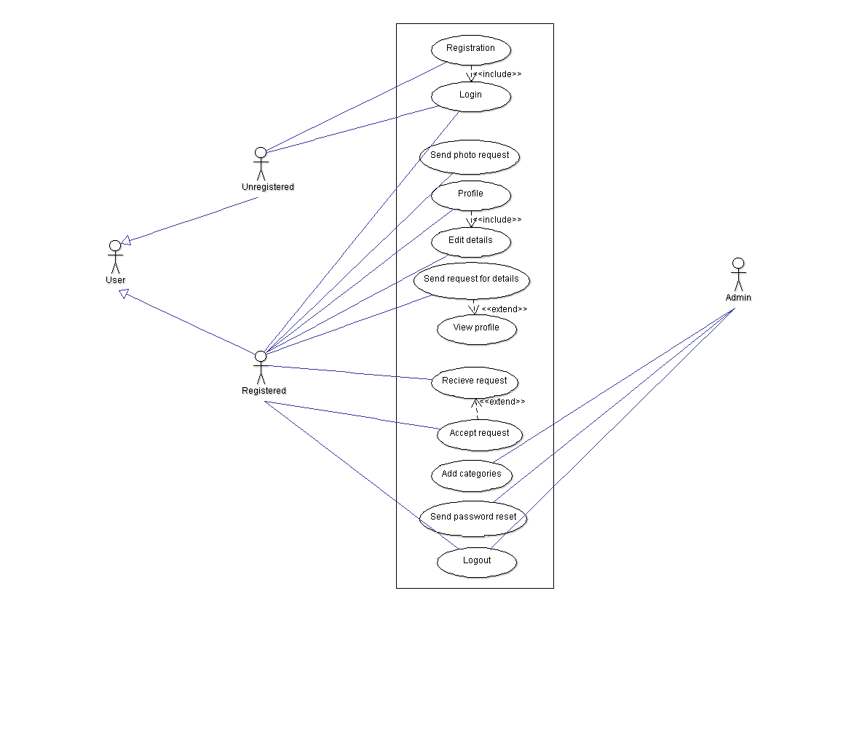



**2.3 USER CLASS AND CHARACTERISTICS**

Other classes includes the support we acquire from other third party software which we use for our face recognition algorithm. Those classes receive the photo and send us back the values which we store in our database. This class relation is currently not shown in the above diagram. The most important class in the system is account class which holds details all the details about the user.

**2.4 OPERATING ENVIRONMENT**

The application works in all android devices with operating system above 4.2.2 which includes requirements of front and rear cameras. These are the required for the software to run successfully.

**2.5 DESIGN AND IMPLEMENTATION CONSTRAINTS**

At present we are not able to handle bandwidth more than 100 GB so, we are limited to 2000 students. Face-plus-plus provides less amount of bandwidth which is not suitable for multiple queries.

**2.6 USER DOCUMENTATION**

The app uses very simple User Interface which is designed keeping in mind User Experience UX. we are not required any manual for polygon and it is introduced with basic help it can be easily understandable for all the mobile users . All the terms and conditions are shown while downloading the app which will available in Android app store.

**2.7 ASSUMPTIONS AND DEPENDENCIES**

There are very few assumed factors in the SRS document. We assumed that there will be no hackers attack over the database until it upgrades to Azure cloud service. If that happens the information in the database will be lost. To avoid this kind of factor we must upgrade before we reach huge audience. The operational cost would increase and also the security issues will be raised if the assumption goes wrong. Polygon uses another web application which is documented and it can be used freely for non-commercial use, as long as polygon is growing it will be a non-commercial application.

**3. EXTERNAL INTERFACE REQUIREMENTS**

**3.1 USER INTERFACES**

The app contains login page at first to allow registered users to login. Login page also directs new users to signup page to create a new account, they need to upload their required data.

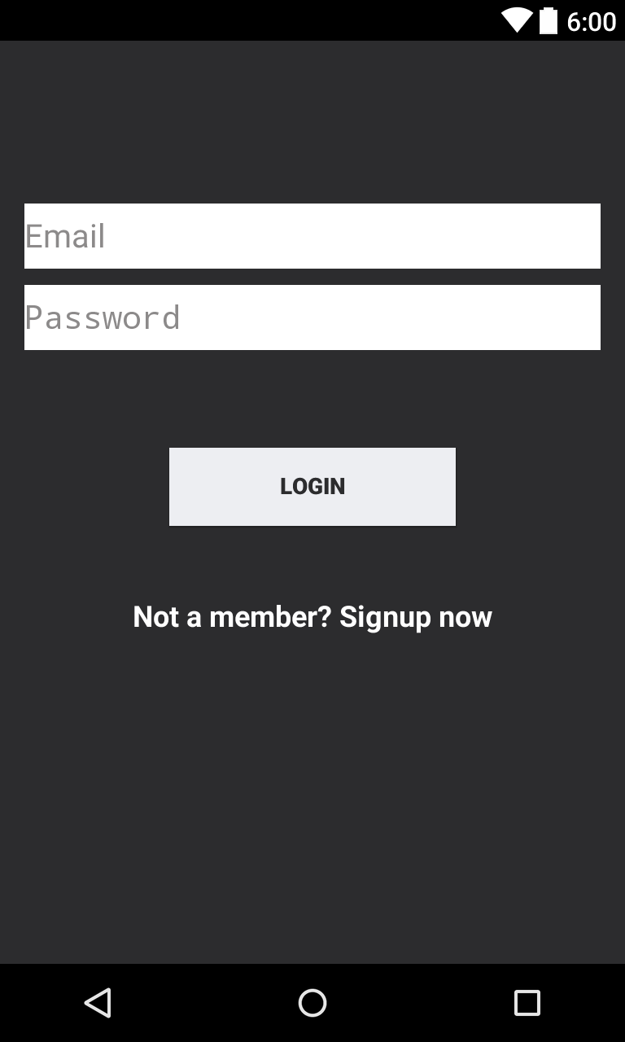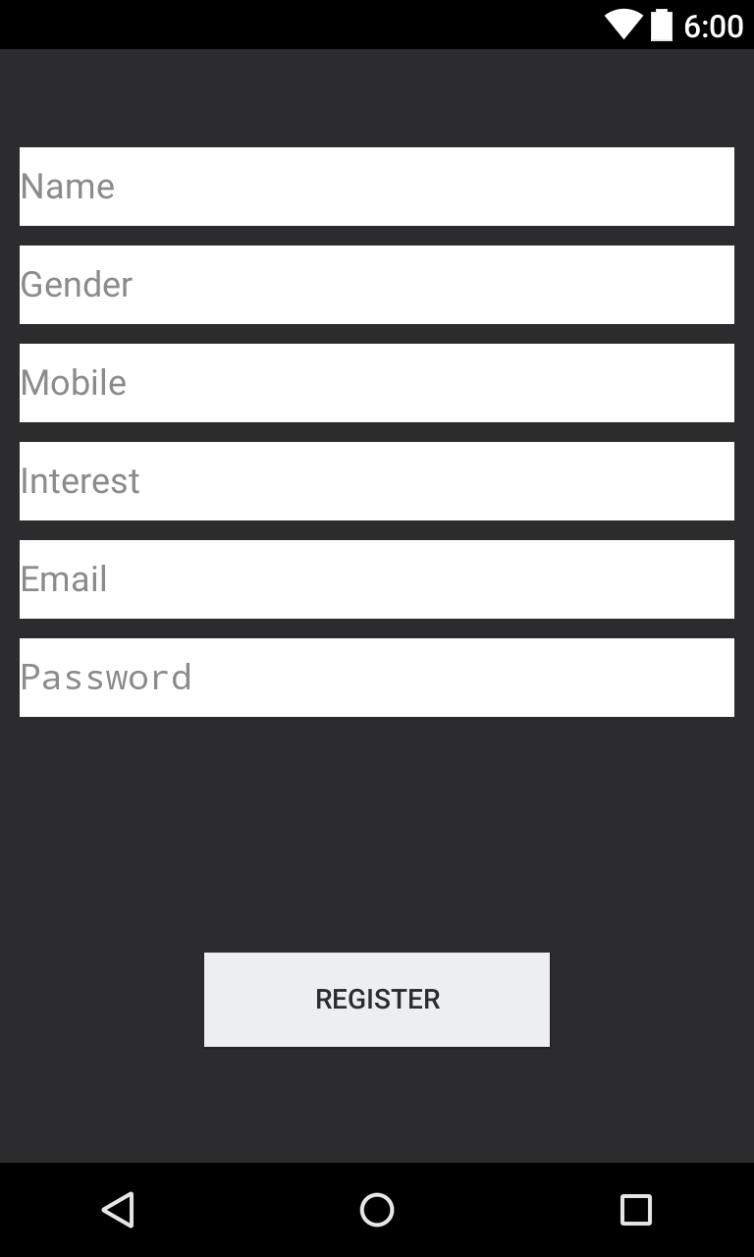

**3.2 HARDWARE INTERFACES**

The application uses database which stores the information regarding the user’s information. If any new user cell is created the database fetches information from face-plus-plus site and stores it. If any request made from other user matches the values of face of other user the details will be returned. The application is currently supported for android OS above 4.2.2 (Android Jelly Bean).

The device requires dual cam front and rear and internet connection.

**3.3 SOFTWARE INTERFACES**

We are using face-plus-plus 1:1 face verification method to detect the face and also to store required face values. Polygon 1.0 also uses 000webhost.com database to store the user’s information. The photo of user is sent to face-plus-plus and the returned values are stored in our database. App currently works in android smart phones with operating system on or above version 4.2.2. Face-plus-plus provides free API support for non-commercial use and 000webhost also provides free database service until we reach 100GB storage. All the data is shared with 000webhost and all the photo requests are shared with face-plus-plus site.

**3.4 COMMUNICATIONS INTERFACES**

The application utilizes communication between different servers and databases web browser and also network server communication. Software uses hypertext transfer protocol and it also uses UTF 8 encoding and the database is also an encrypted database. We have 100GB bandwidth which can handle the current population.

**4. SYSTEM FEATURES**

# 5. OTHER NONFUNCTIONAL REQUIREMENTS

**5.1 PERFORMANCE REQUIREMENTS**

If a person requests for query the database takes information from face-plus-plus site and starts its search in the database then sent back their values. The system is a real time system as the query is made real time and so the system should be more specific and more efficient. We used MYSQL for the present data.

**5.2 SAFETY REQUIREMENTS**

The database is secured and other actions that are against the terms will be terminated and necessary actions will be taken.Microsoft’s azure is used for back up by doing this data will be saved from server crashes

**5.3 SECURITY REQUIREMENTS**

This application has very few security problems regarding stealing of information of other people which have been taken into account. Everyone who uses this app should agree to the terms of usage. The issue is taking pictures of others without their permission, for this purpose we had a solution, everyone can keep all their information private and if someone takes their photo a notification will be sent to that person that you have been photographed and details of the person who took will be also sent.

**5.4 SOFTWARE QUALITY ATTRIBUTES**

Polygon is a next generation concept which take some time, it will be available for all members in NIIT University by end of November. This application will be more accurate and more useful .it is easy to operate in mobile devices. It is portable to you same account in different movie devices.

**5.5 BUSINESS RULES**

This is like fb but it is not exactly like fb.

.all the team members are requested to look the data and that is entered in database and observe the servers. The management team should create link with other colleges and organizations to know about their student’s .and their activities

**6. OTHER REQUIREMENTS**

The role of the application is to update the status of the person. And stay connected with others …..